# Accounting voucher:

A voucher is a document that contains details of a financial transaction and is required for recording the same into the books of accounts. For every transaction, you can use the appropriate Tally voucher to enter the details into the ledgers and update the financial position of the company. The voucher entry menus options are available under Transactions in the Gateway of Tally. The Payroll and Order Vouchers are available as separate options which can be enabled based on the requirements. The Payroll Vouchers can be enabled from F1: Accounting Features, whereas the Order Vouchers can be activated from F2: Inventory Features.

***Gateway of tally***

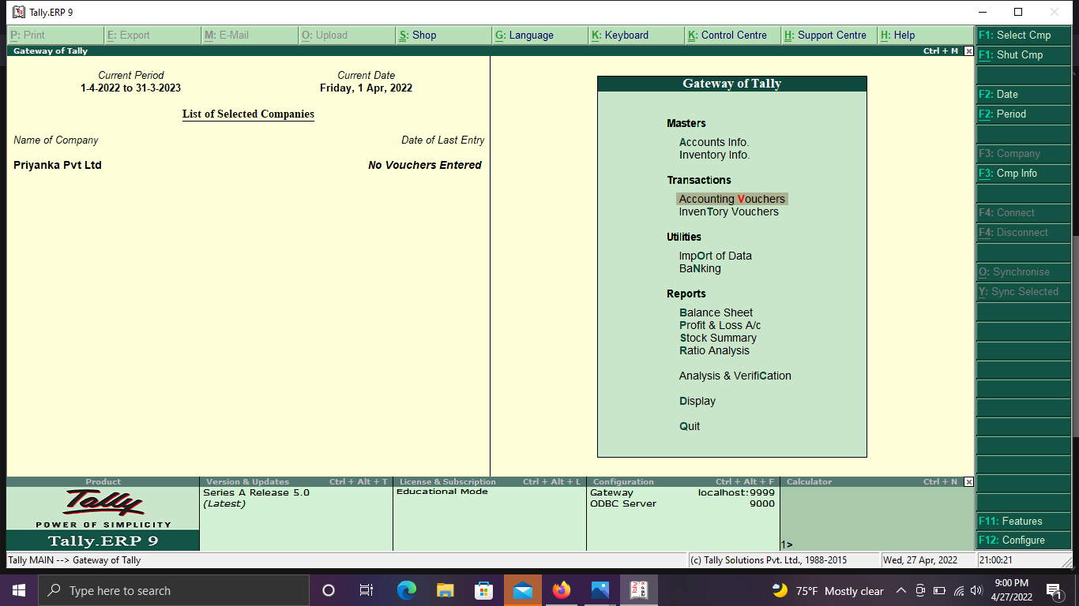

# Pre-defined Voucher:

Tally comprises of the following predefined Vouchers, to suit different business requirements for recording various transactions. Tally also allows you to create user-defined Vouchers (Voucher Types) as per your requirements.

* Contra Voucher
* Payment Voucher
* Receipt Voucher
* Journal voucher
* Sales Voucher / Invoice
* Debit Note Voucher
* Credit Note Voucher
* Purchase Voucher / Invoice
  + ***Shortcut with predefined vouchers in tally interface***

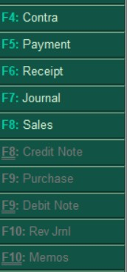

# Contra Entry:-

In the dual entry accounting system, a contra entry is an entry which is recorded to **reverse** or **offset** an entry on the other side of an account. If a debit entry is recorded in an account, it will be recorded on the credit side and vice-versa. Debit and credit aspects of a single transaction are entered in the same account but in different columns. Each entry, in this case, is viewed as a contra entry of the other. Remember the word contra as **“Against”** or **“Opposite”.** The Contra Voucher can be recorded using Single entry mode or Double Entry Mode. To toggle between Single Entry and Double Entry mode, we need to change the setting Use Single Entry mode for Payment/Receipt/Contra to Yes/No in **F12: Configure.** As per the Accounting Principles, a Contra entry is a transaction involving transfer of cash between one Cash A/c to another or one Cash A/c to another Bank A/c i.e., is a transaction indicating transfer of funds from:

* Cash account to Cash account
* Cash account to Bank account
* Bank account to Cash account
* Bank account to Bank account

# To create a Contra Entry.

To view Contra Voucher creation screen in Single Entry mode,

1. 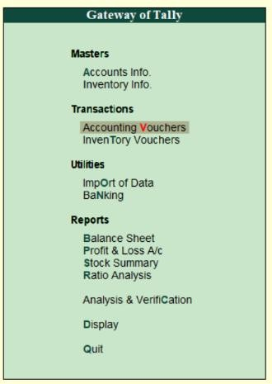Go to **Gateway of Tally.**
2. Click on **Accounting Vouchers**.
3. Click on right side in **F4: Contra.**

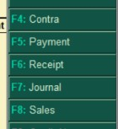

1. for example, to transfer funds from Cash Account to Bank Account:
   * Debit the Bank Account.
   * Credit the Cash Account.

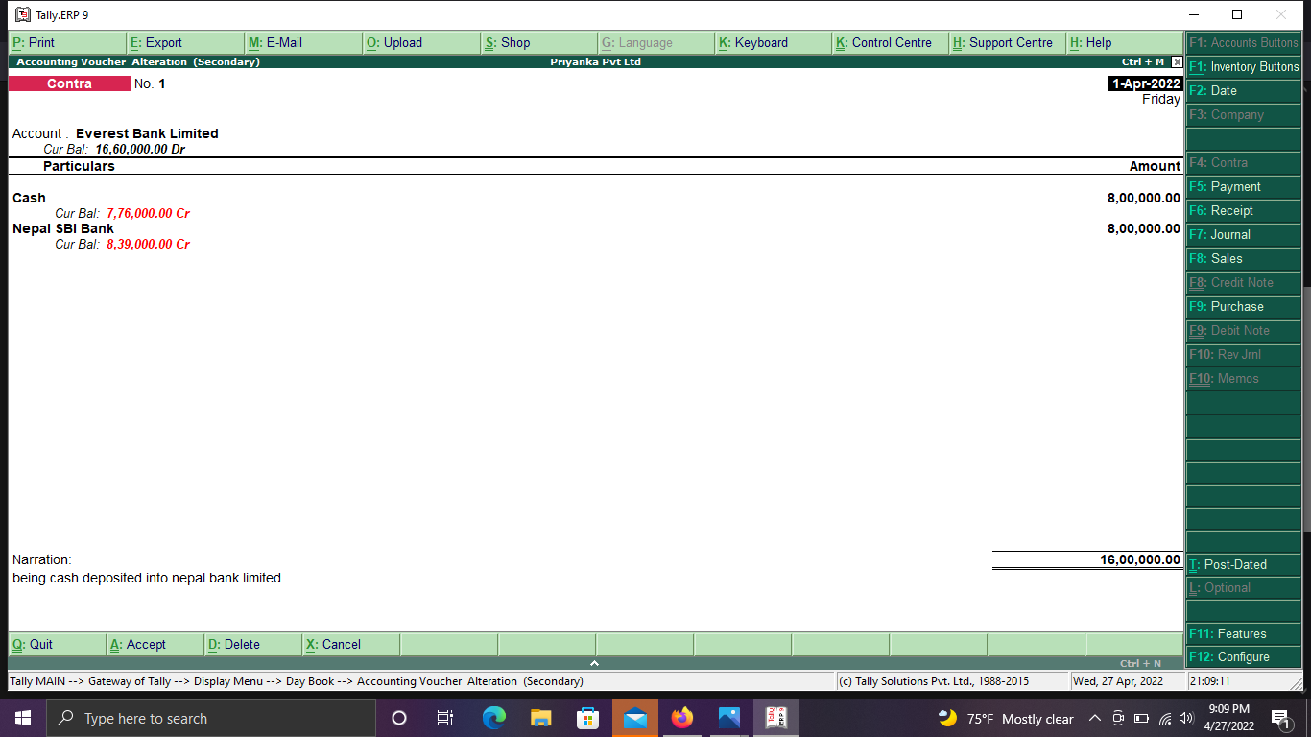

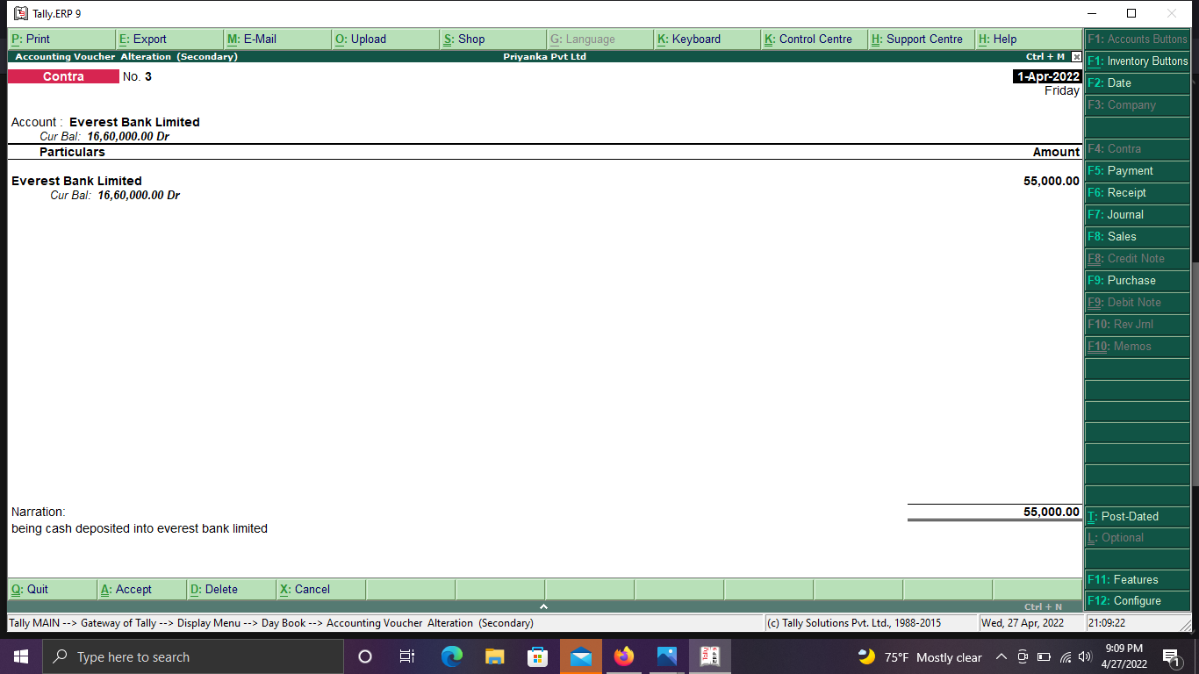

# Deposit {Contra (F4)}

Deposit is the cash received by the bank or when the person keeps balance in the bank. Deposit is current liability account in general ledger, in which is stored the amount of funds paid by customer in advance of product or service delivery. Example:

Credit: - priyank kharel

Amount: - 10,00,000.00

## Cash deposited into the nepal Bank Rs. 8,00,000.00

Nepal Bank a/c Dr… 8,00,000.00

To, Cash a/c… 8,00,000.00

## Cash deposited into the Everest Bank Rs. 55,000.00

Everest Bank a/c Dr… 55,000.00

To, Cash a/c… 55,000.00

The deposited entry will be displayed as shown:



# Withdrawn (Contra [F4])

It is the process of taking money back from bank by the owner. It also involves contra entry. The Cash Withdrawals from Bank report provides the details of Total Amount Withdrawn from bank during the Audit year, along with the voucher count. Example:

## Cash withdrawn from Nepal Bank Rs.60,000.00

Cash a/c Dr 60,000.00

To, Nepal Bank a/c 60,000.00

## Cash withdrawn from Nabil Bank Rs60.,000.00

Cash a/c Dr………………………..60,000.00

To, Nabil Bank a/c 60,000.00

The deposited entry will be displayed as shown:

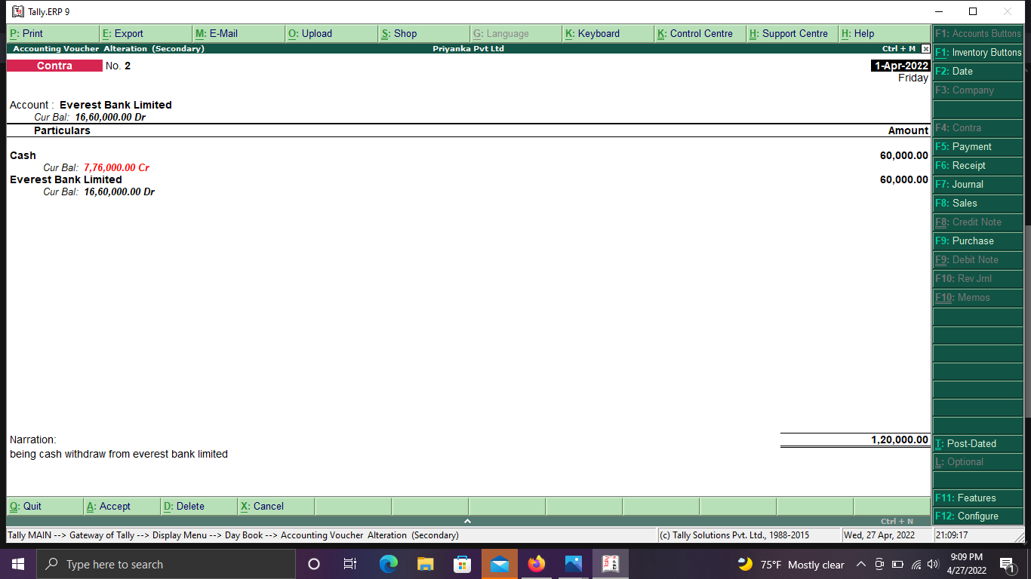

# Receipts:-

Receipts are the amount of cash a business takes in during any one accounting period. Receipts are cash sales, as well as money received on a customer's account. Receipts also include any cash received in the business from any source, including loan or credit line proceeds or funding from investors.

Any money received from debtors against sales Invoices or on Account and for all transactions where money is received are accounted or entered into Tally.

# To create a Receipts Entry.

To view receipts voucher creation screen in Single Entry mode,

* 1. Go to **Gateway of Tally.**
  2. Click on **Accounting Vouchers**.
  3. Click on right side in **F6: Receipt.**



Examples-

## Commission received of Rs. 78,000.00

Cash a/c Dr Rs. 78,000.00

To commission received a/c ……………… Rs. 78,000.00 When we entry these receipt in tally:

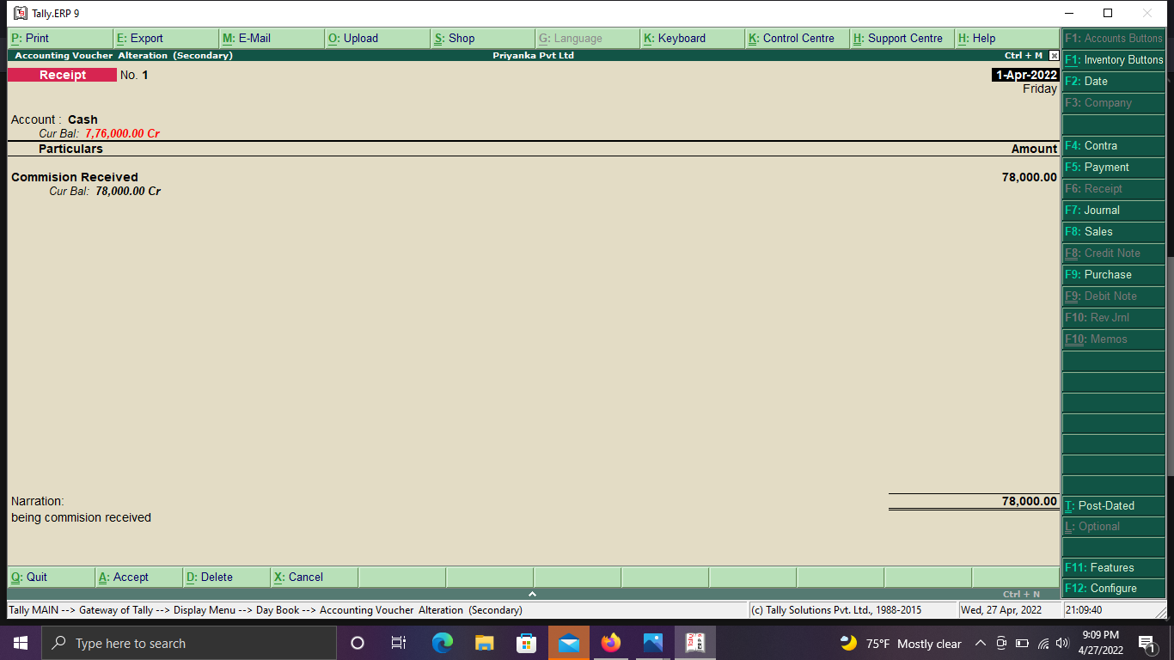

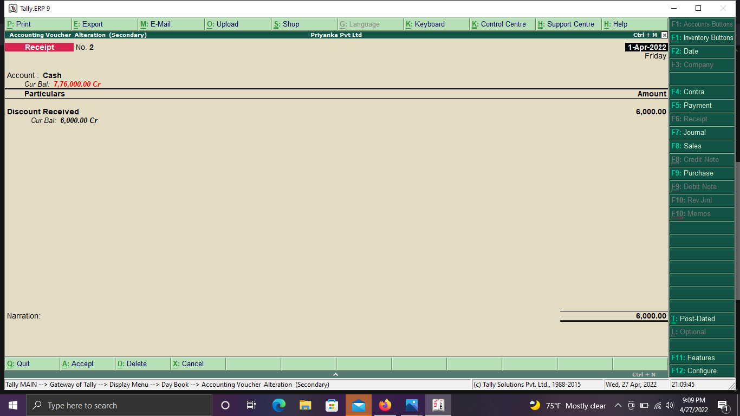

**Payment:-**

Payment is the transfer of money, goods, or services in exchange for goods and services in acceptable proportions that have been previously agreed upon by all parties involved. A payment can be made in the form of services exchanged, cash, cheque. Payments can be the transfer of anything of value or benefit to the parties. An [invoice](https://www.investopedia.com/terms/i/invoice.asp) or bill typically precedes a payment. Payees usually get to choose how they will accept payment.

# To create a Payment Entry.

To view payment voucher creation screen in Single Entry mode,

* 1. Go to **Gateway of Tally.**
  2. Click on **Accounting Vouchers**.
  3. Click on right side in **F5: Payment.**



Examples:

## i. Rent paid of Rs. 30,000.00

Rent a/c Dr Rs. 30,000.00

To cash a/c……………………..Rs. 30,000.00 When we enter these payments entries in tally:

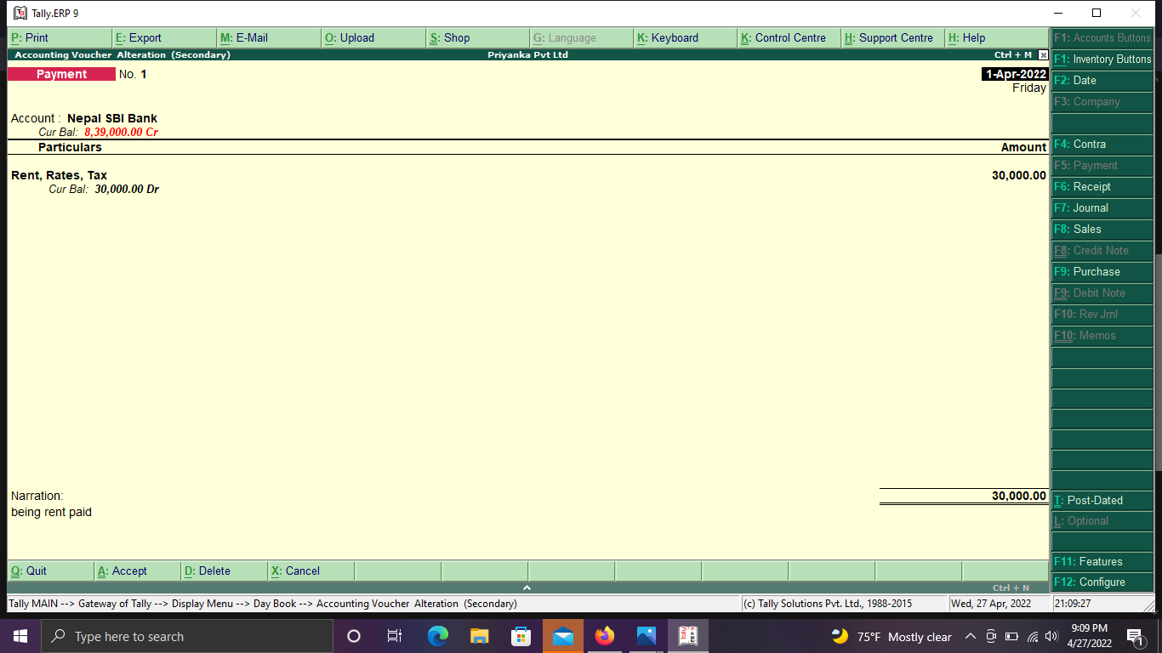

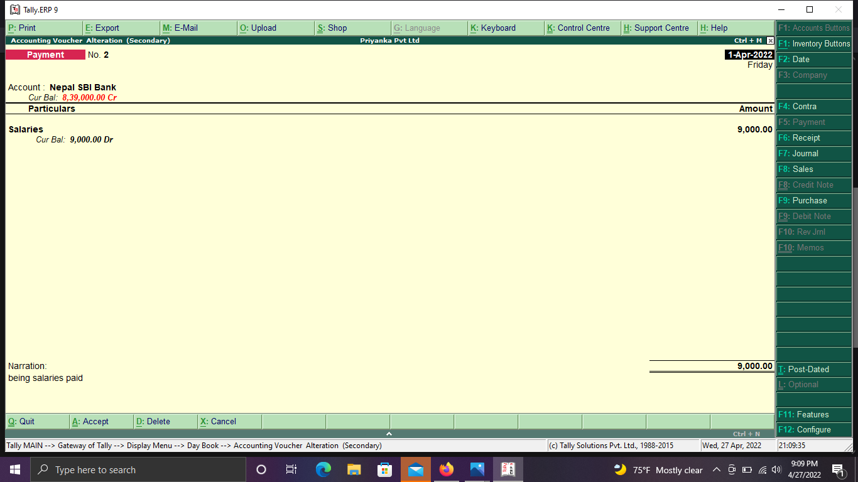

To view all the entries of **contra, receipts, payment** we have to follows the following steps:-

* Go to **Gateway of Tally.**
* Click on **Display** on Reports Section.

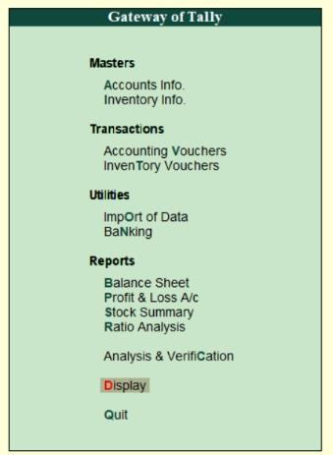

* Click on **Day Book.**

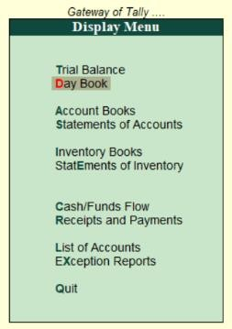

* And see the all entries.

